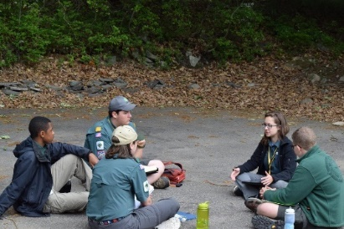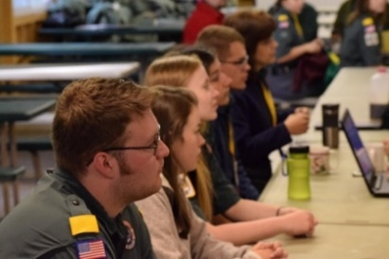

**Price:** $50.00 per person

Includes: All materials, activities, food, and cabin/tent camping for the entire weekend!

**Where:** Just outside of NYC, only 10 miles north of the George Washington Bridge, in the heart of Alpine, New Jersey.

Camp Alpine   
441 Route 9W  
Alpine, NJ 07620

www.alpinescoutcamp.org

June 9-11, 2017

**NER Venturing Leadership Conference**

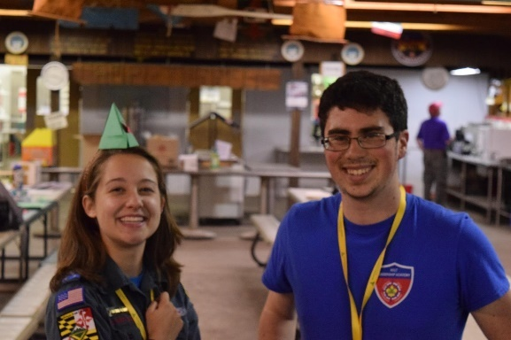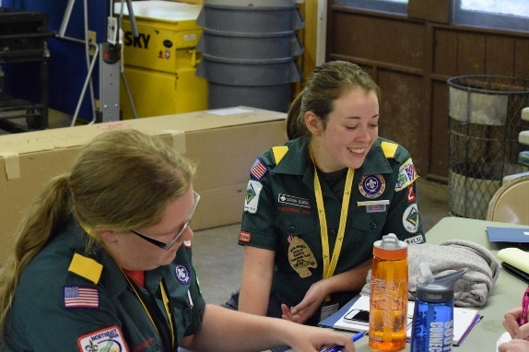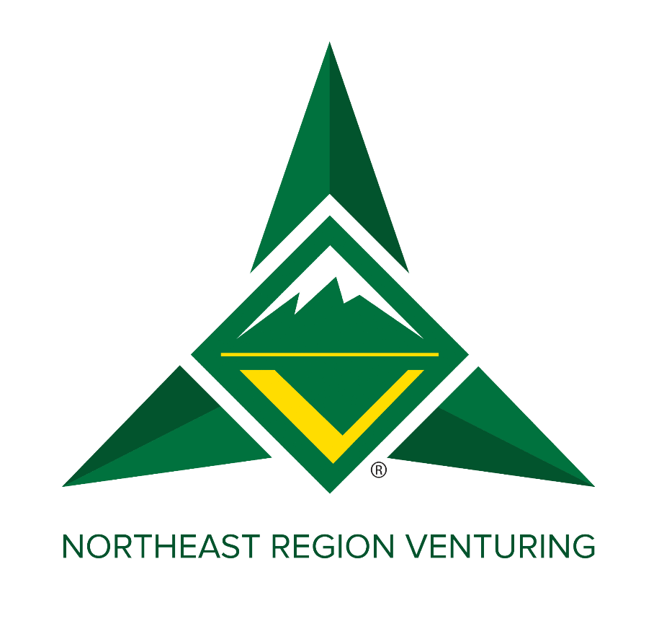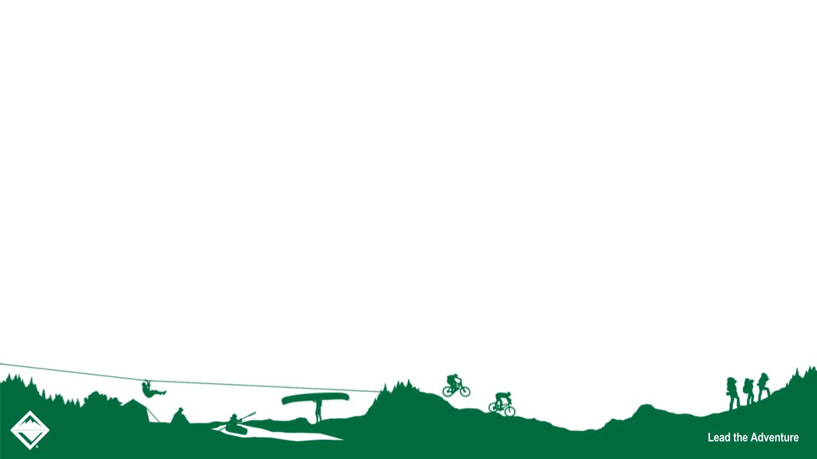

The NER Venturing Conference will be an opportunity for the Region VOA, each NER Area VOA, and each NER Council VOA to come together and create actionable plans for change and improvement in the Region and Areas for the 2017-2018 Term.

Besides being an opportunity to develop goals and plans as a Region for the coming year, the NER Venturing Conference will provide a fun and engaging forum for open conversation and problem solving for all VOA Officers and some special guests on common problems facing VOAs across the Nation and how to solve them.

Bring your ideas and open minds to the table. We look forward to having fun and working with you all!  
  
Watch **nerventuring-bsa.org** and our Facebook page *Northeast Region Venturing* for updates!